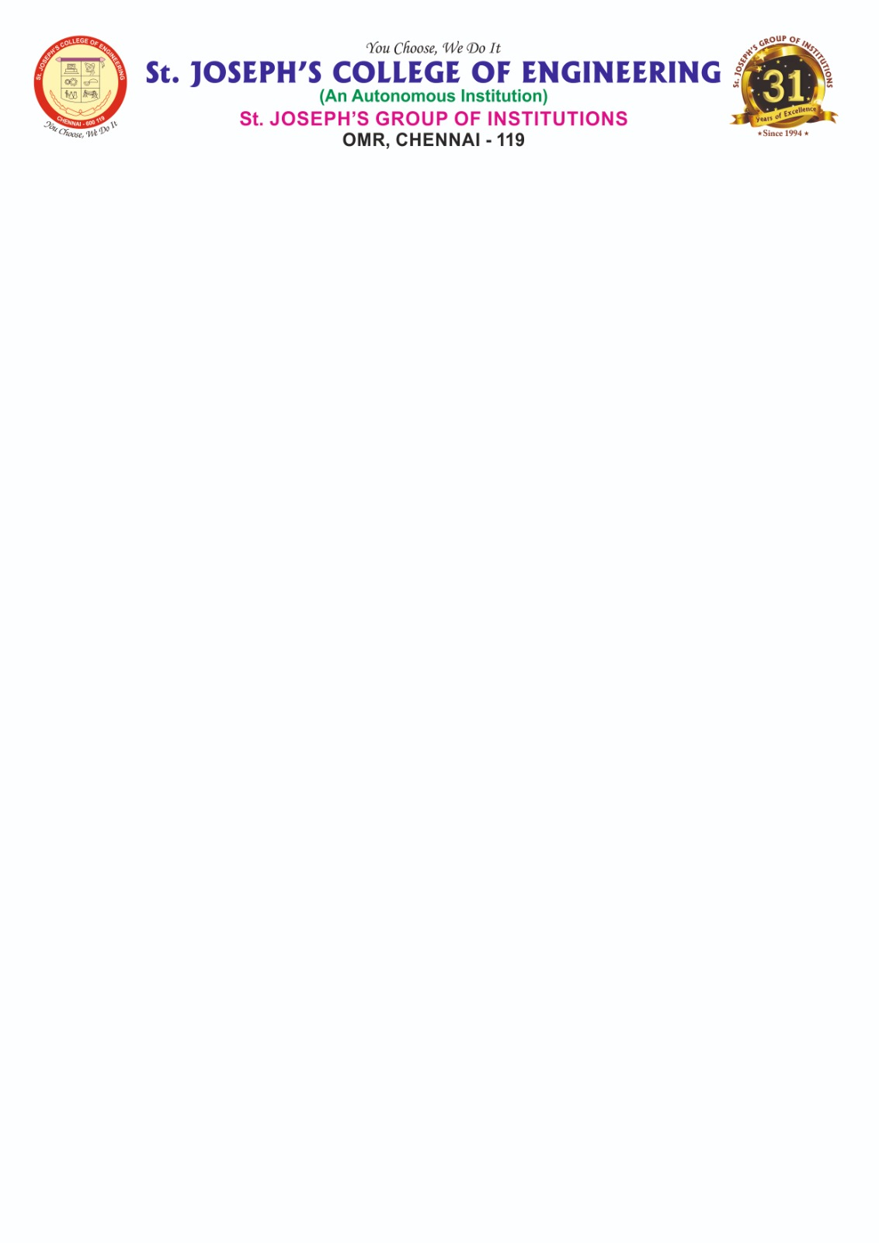

**DEPARTMENT OF INFORMATION TECHNOLOGY**

**AD1006 - Unnat Bharat Abhiyan (UBA)**

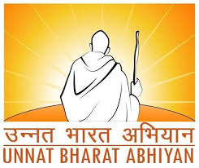

**FOCUSSING AREA:**

**MENTAL AND HEALTH**

**LOCATION:**

**Thenneri, Kanchipuram District, Tamil Nadu**

**REPORT**

**Submitted by**

**SANJAY SIDDHARTHAN 312321205143**

**SHADRACH MATTHEW 312321205150**

**UBA Focusing Area Mapping with SDG and Justification**

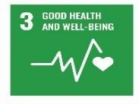

The UBA project on Special Care for Physically Challenged People strongly aligns with **SDG 3: Good Health and Well-being**, which emphasizes ensuring healthy lives and promoting well-being for all at all ages. One of the major objectives of our project was to improve access to health services for differently abled individuals in the village of Thenneri**.**

As part of our intervention, we conducted a door-to-door survey to identify physically challenged individuals and assess their health conditions. We then coordinated with the local Primary Health Centre (PHC) to organize a basic **medical screening camp,** where preliminary check-ups were carried out. This helped initiate the process for disability certification and connected individuals to further medical support**.**

Our project also raised awareness among families about the importance of regular check-ups, government health schemes, and the availability of assistive devices through programs like the ADIP scheme. These efforts aimed to ensure that the health needs of physically challenged persons are recognized and addressed, contributing directly to the goals of SDG 3 at the grassroots level.

**INTRODUCTION**

Rural development remains one of the most critical components in India’s journey towards inclusive and sustainable growth. With the majority of the population residing in villages, addressing the needs and challenges of rural communities is vital. As part of the UBA initiative, our student team from St. Joseph’s College of Engineering adopted Thenneri village in Kanchipuram district, Tamil Nadu. The objective was to assess the prevailing health conditions and propose practical interventions, particularly focusing on enhancing primary healthcare access and awareness among the underserved. Thenneri, with its significant population and low female literacy rate, faces serious health challenges including lack of local medical infrastructure, poor emergency response systems, and limited hygiene awareness. The project was undertaken directly by our UBA student team through intensive community interaction and participatory methods. Our activities included:

* Conducting door-to-door surveys to identify common health issues and undeserved groups.
* Interacting with village residents and local panchayat leaders to assess gaps in healthcare access.
* Organizing a free medical camp in collaboration with local health professionals.
* Launching awareness programs on maternal health, sanitation, nutrition, and first aid.

By the end of the project, dozens of families had accessed basic health services, women received guidance on menstrual and maternal health, and the community expressed a strong willingness to continue local health initiatives. Our goal now is to build upon this progress by establishing self-sustaining health SHGs and strengthening ties with healthcare providers to ensure long-term wellness for Thenneri’s residents.

**OBJECTIVES OF THE PROJECT**

The primary focus of this project under the Unnat Bharat Abhiyan was to improve the living conditions and opportunities on **Medical and Health** in the village of Thenneri. Based on interactions with the villagers, surveys, and situational analysis, the following specific objectives were defined and achieved by our student team:

# Identification of Beneficiaries

# To conduct a comprehensive household-level health survey in Thenneri to identify individuals with untreated or chronic medical conditions, maternal health concerns, elderly care needs, and limited access to healthcare services.

# Assessment of Existing Challenges

# To evaluate the barriers villagers face in accessing timely medical care, emergency services, preventive health information, and basic hygiene infrastructure, especially among women and children.

# Create Awareness on Rights and Government Schemes

# To organize awareness sessions on sanitation, menstrual hygiene, and maternal care, while educating families about available health-related government schemes such as the Chief Minister’s Comprehensive Health Insurance Scheme (CMCHIS), Janani Suraksha Yojana, and local PHC services.

# Facilitate Access to Medical Support

To coordinate with the local Primary Health Centre (PHC), mobile medical units, and NGOs to organize free medical camps, health check-ups, and vaccination drives, and assist villagers in getting referred care, medications, or follow-up support.

# Propose Health Infrastructure Enhancements

# To assess the need for installing hand-washing stations, first-aid points, and creating clean waiting areas near schools and anganwadis, and to submit infrastructure improvement proposals to the panchayat.

# Promote Community-Based Health Workers

# To identify and train village volunteers (especially women and youth) in basic first aid, maternal health support, and health record-keeping so they can act as first responders and community health educators.

**Foster Long-Term Health Engagement**

To initiate the formation of health-focused SHGs or volunteer groups that can continue organizing awareness drives, maintain emergency contact networks, and promote healthy habits beyond the project’s timeline.

Through these objectives, our team aimed not only to address the visible and invisible gaps in rural healthcare but also to empower the Thenneri community with knowledge, access, and local leadership. These efforts are directly aligned with the vision of Unnat Bharat Abhiyan and contribute to the creation of a healthier, more resilient rural society.

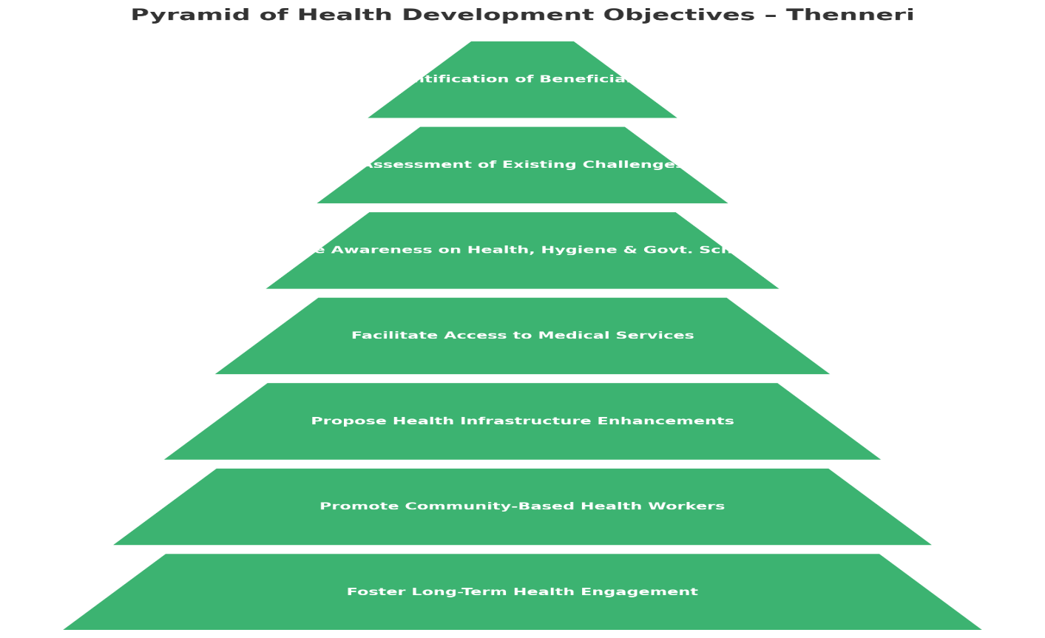

**VILLAGE PROFILE – THENNERI**

**Thenneri** is a prominent rural settlement located in the Kanchipuram Taluk of Kancheepuram District, Tamil Nadu. It is situated approximately 9 kilometers north of the district headquarters Kanchipuram, and around 60 kilometers from Chennai, the state capital. The village falls under the postal code 631502. It is bordered by the Walajabad Block to the east and the Sriperumbudur Block to the north-east, with close connectivity to major highways and minor towns.

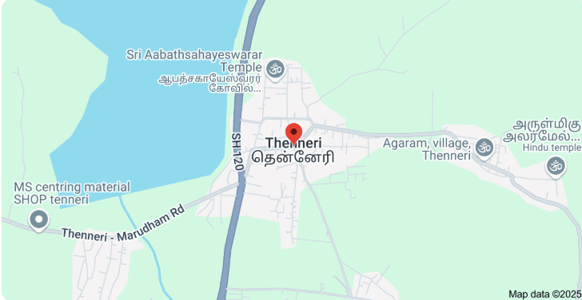

According to the baseline survey conducted by our team in association with data from the UBA household study, the total geographical area of Thenneri village is 586 hectares. The village has a population of approximately 2,100 individuals, comprising around 1,055 males and 1,045 females. There are 546 households in total, with an average family size of approximately 3.8 members. Tamil is the primary language spoken in the village, although some youth are also able to communicate in English.

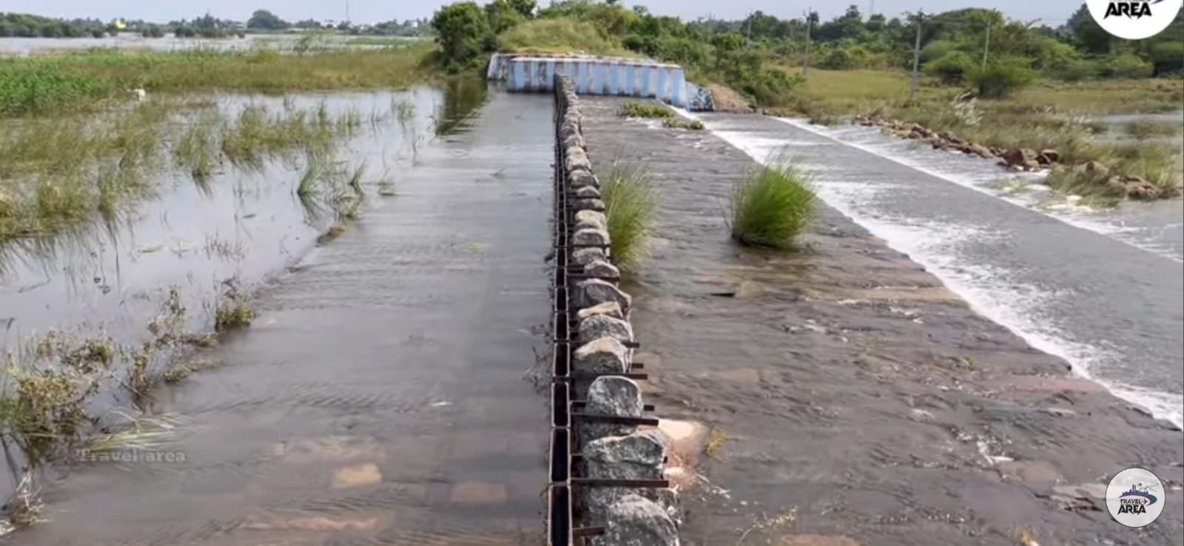

**Geographical and Demographic Details:**

Based on the baseline survey conducted by our student team under the Unnat Bharat Abhiyan (UBA) initiative and supported by village-level data, Thenneri encompasses a total geographical area of **586 hectares**.

* **Total Population:** 2,100 individuals
* **Gender Ratio:** Approximately 1,055 males and 1,045 females
* **Total Households:** 546
* **Average Family Size:** Approximately 3.85 members
* **Primary Language:** Tamil (Basic understanding of English among some youth)

Thenneri displays a relatively balanced gender ratio and a moderately sized population. Despite having basic infrastructure, the village faces certain socio-economic challenges, particularly in areas related to education, healthcare access, women's empowerment, and digital awareness.

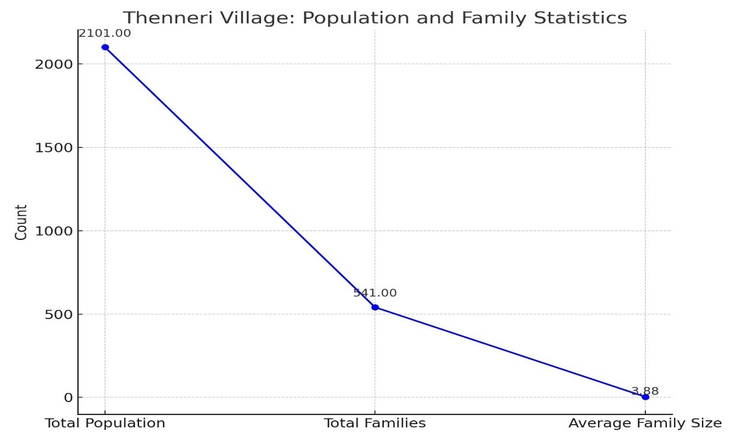

Thenneri village is equipped with essential amenities such as a primary school, an Anganwadi center, a Public Distribution System (PDS) shop, and access to a nearby Primary Health Centre (PHC). However, it lacks facilities and services specifically designed for persons with disabilities. While transport to nearby towns is available, it remains largely inaccessible to the physically challenged. Our survey identified significant gaps, including the absence of ramps in public buildings, a shortage of mobility aids, limited awareness of government welfare schemes, and the complete lack of vocational training opportunities for differently-abled individuals.

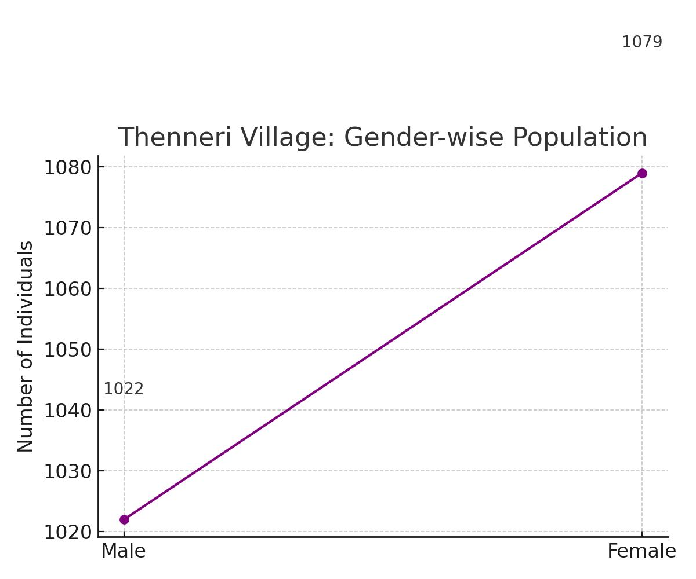

**BASELINE SURVEY AND IDENTIFICATION OF MEDICAL AND HEALTH CONDITIONS:**

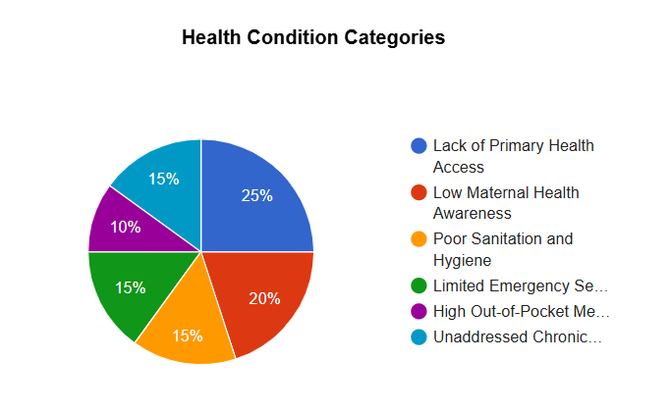

*Figure 1: Distribution of Medical and Health of Thenneri Village (Sample- based Data)*

# To gain a thorough understanding of the medical and health condition of physically challenged individuals in Thenneri, our UBA student team conducted a detailed door-to-door baseline household survey. The primary objective of this survey was to identify the number of differently-abled individuals in the village, understand the nature of their disabilities, evaluate their current living conditions, and assess their access to government health and welfare schemes. Covering all 396 households, the survey ensured that every segment of the population was represented and that the data collected was both inclusive and accurate.

# In total, 1,504 individuals were surveyed, out of which 25 were identified as physically challenged—representing approximately 1.66% of the village’s total population. The breakdown of disabilities revealed that 56% suffered from mobility impairments, 24% had visual impairments, 12% had hearing difficulties, and the remaining 8% were affected by other issues such as speech or neurological disorders. This data helped our team classify the healthcare support required and understand the priority medical needs within this population group.

# Observations:

# Several critical observations emerged from the survey on the medical and health conditions of physically challenged individuals in Thenneri village. Many individuals with mobility impairments lacked basic assistive tools such as wheelchairs or crutches, severely restricting their independence. Additionally, public infrastructure, including schools, anganwadi centers, and Panchayat buildings, lacked accessibility features like ramps and handrails, further isolating them from social and civic activities.

# The impact on education was notable, with many children and youth dropping out due to inaccessible school buildings and lack of transport or social support. Additionally, more than half of the surveyed individuals were unaware of government health and welfare schemes, such as medical assistance and disability pensions, limiting their access to necessary services.

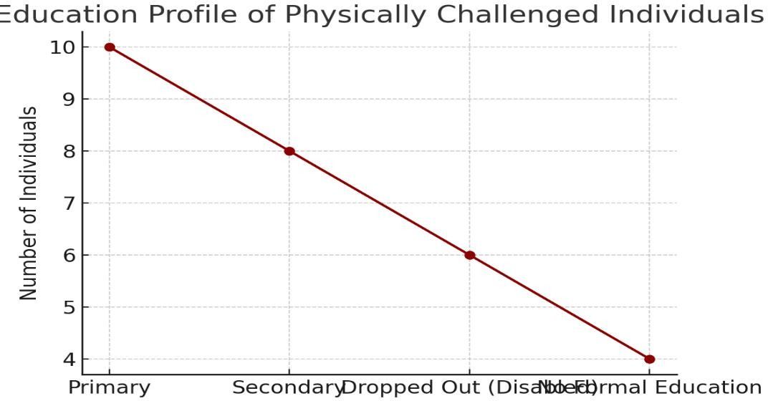

**CHALLENGES FACED BY PHYSICALLY CHALLENGED INDIVIDUALS:**

During our extensive household survey and interactions in Thenneri village, several pressing challenges were identified that impact the lives of individuals affected by medical and physical disabilities. These challenges not only affect their daily living but also hinder their long-term well-being, dignity, and participation in community life.

One of the most critical issues observed was the lack of accessible physical infrastructure. None of the public buildings in the village—including schools, anganwadi centers, or the Panchayat office—were equipped with ramps, handrails, or other inclusive design features. Village roads were often narrow, uneven, and poorly maintained, creating significant mobility barriers, especially for individuals who require wheelchairs or walking aids.

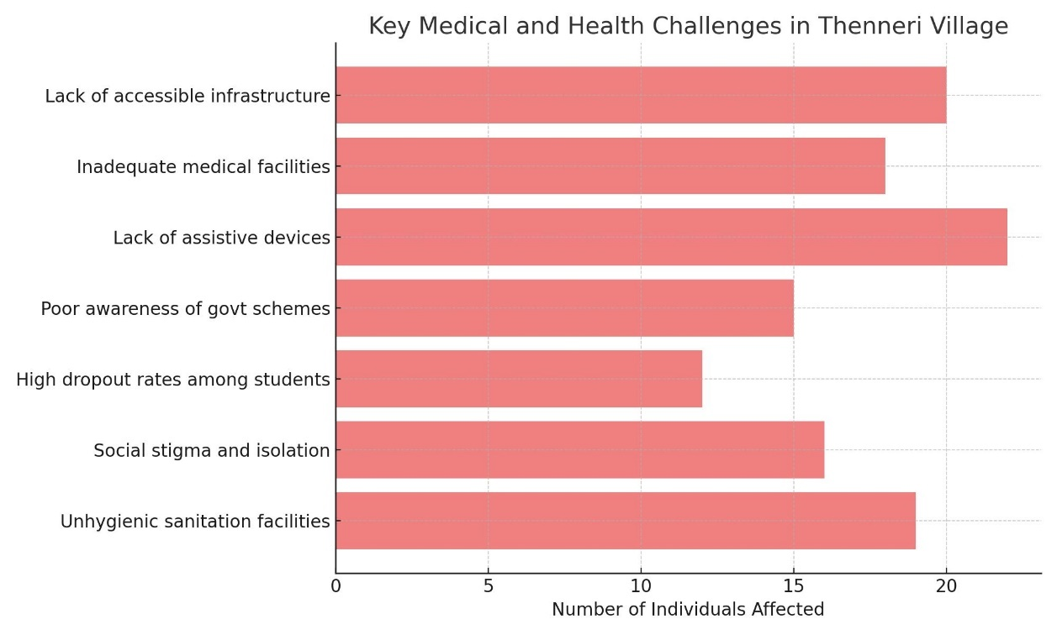

**Access to mobility aids** is another pressing concern. Out of the 28 physically challenged individuals identified, only a handful had access to wheelchairs or walking sticks. Most families cited cost and unawareness about government

provision of free aids as major reasons. As a result, many individuals are homebound and dependent on family members for basic mobility.

**Educational challenges** are equally significant. Physically challenged students are often forced to drop out due to a lack of support in schools, such as ramps, special educators, or transport facilities.

A major issue we observed was the **lack of awareness about government schemes**. Most individuals were unaware of the UDID card, disability pension, and assistive device distribution schemes.

Lastly, **economic exclusion** remains a critical challenge. None of the individuals surveyed were employed, nor did they have access to skill-building or livelihood opportunities. Their families often face additional financial strain, as caregivers are forced to stay home, thereby reducing household income potential.

These challenges are deeply interconnected and require a holistic and sustained approach to resolution. They served as the foundational motivation for our awareness drives, medical camps, and proposal submissions during the course of this project.

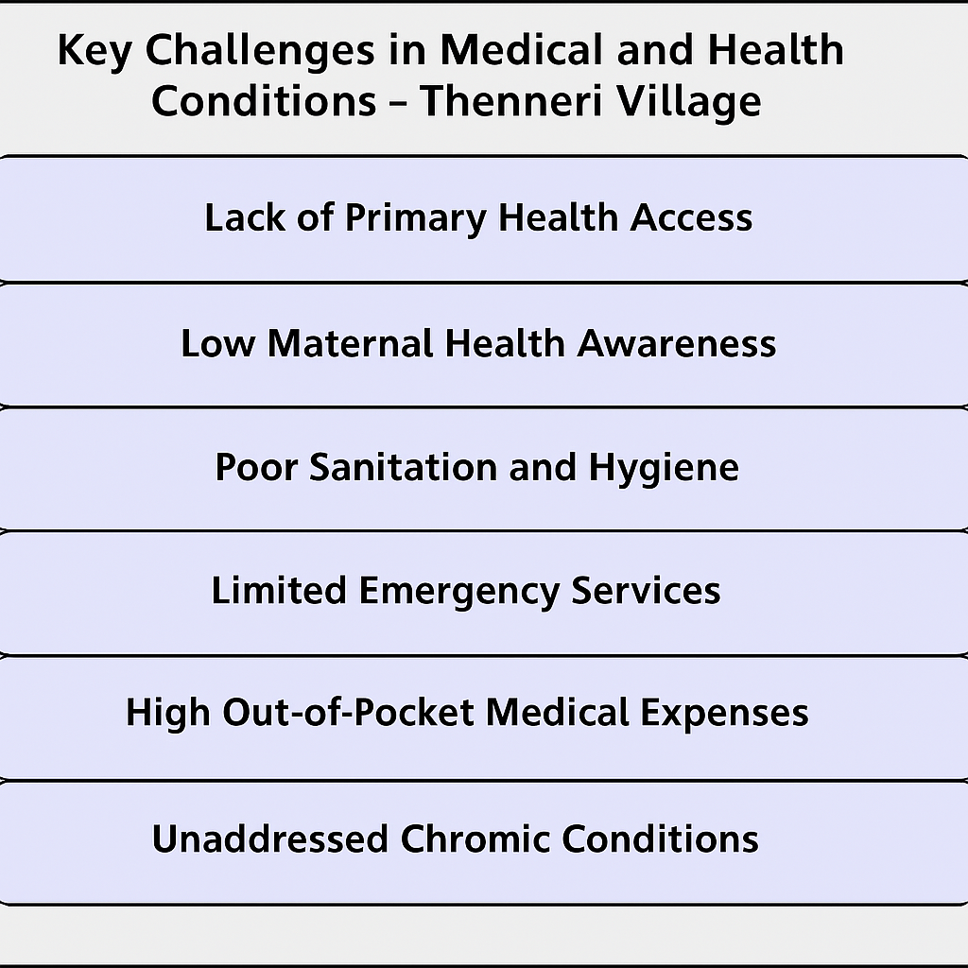

**GOVERNMENT SCHEMES AVAILABLE FOR MEDICAL AND HEALTH CONDITON BASED INDIVIDUALS**

As part of our project in Thenneri village, a key focus was on raising awareness about government schemes available for individuals affected by health and medical conditions. Our household survey revealed that many eligible residents were either unaware of these schemes or unsure about how to access them. To bridge this information gap, our team gathered verified details from official Tamil Nadu and central government sources. We then shared this information with the community in simple, easy-to-understand formats through posters, handouts and counseling sessions.The following are some of the major government schemes introduced to the residents to support their medical and health-related needs:

**1.Chief Minister’s Comprehensive Health Insurance Scheme (CMCHIS)**

Provides free health insurance coverage up to ₹5 lakh per family per year.  
This scheme ensures that families with medical and disability needs can access major treatments without financial burden

* + *.***Eligibility:** All residents of Tamil Nadu, especially those with disabilities and low-income families.
  + **Benefits:** Free health insurance coverage up to ₹5 lakh per family per year for major treatments**.**

**2.Indira Gandhi National Disability Pension Scheme**

Offers a monthly pension of ₹1,000 to individuals aged 18 and above with 80% or more disability .It helps meet the basic daily needs of individuals who are unable to work due to severe conditions.

* + **Eligibility:** Individuals aged 18+ with 80% or more disability from BPL (Below Poverty Line) households.
  + **Benefit:** ₹1,000 monthly pension to support daily living expenses.

**3.Maintenance Allowance Scheme**

Implemented by the Ministry of Social Justice and Empowerment, this scheme provides assistive devices such as wheelchairs, tricycles, crutches, and hearing aids to eligible beneficiaries.

* + **Eligibility:** Individuals with 40% or more disability, including those with intellectual or multiple disabilities
  + **Benefit:** ₹1,500 monthly allowance for healthcare, nutrition, and personal care.

# 4. Provision of Aids and Appliances

Supplies devices like wheelchairs, hearing aids, and artificial limbs to eligible individuals.This improves the independence and quality of life for people with mobility or sensory challenges.

* + **Eligibility:** Persons with disabilities certified by the government medical authority.
  + **Benefit:** Free mobility and assistive devices like wheelchairs, hearing aids, and prosthetics.

# 5. Marriage Assistance Schemes

Provides financial support for marriages involving individuals with disabilities.The scheme encourages social inclusion and helps reduce stigma around disability in society.

* + **Target Areas:** Government buildings, schools, transport systems
  + **Scope for Village:** Ramp installation in Panchayat buildings, PHCs, and schools

We conducted an **Awareness Camp** where these schemes were explained to the villagers in Tamil using real-life examples. Application support was provided to families on the spot. As a result, 14 individuals initiated the UDID card application process, and 8 families submitted documents for the disability pension scheme.

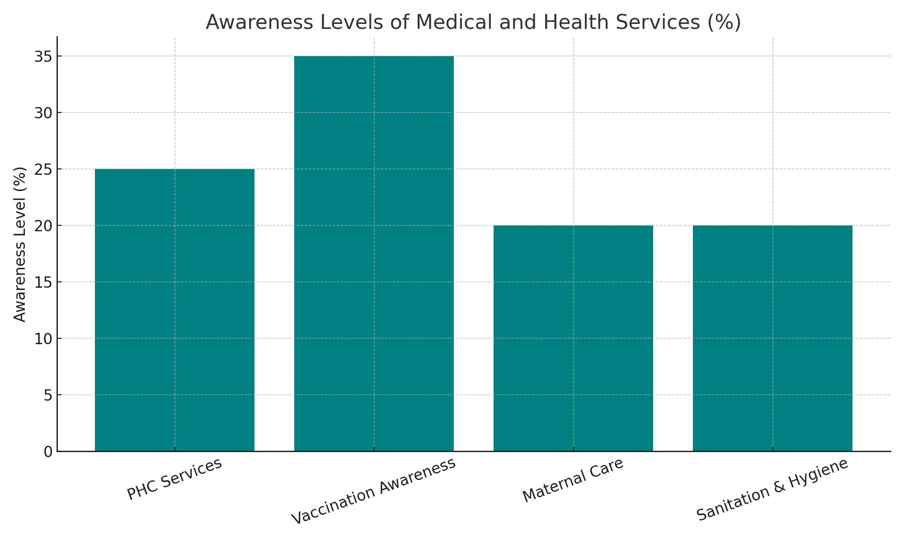The goal of this intervention was not only to inform but also to **empower the villagers** to claim their rightful benefits and become more integrated into the development framework. These schemes, if utilized correctly, can significantly uplift the lives of differently-abled individuals and their families.

**ACTIVITES**

As part of our Unnat Bharat Abhiyan (UBA) project, my partner and I visited Thenneri village and conducted a range of activities over few days. Each activity was carefully planned and executed with the goal of supporting people who are suufering from severe illness in the village and raising awareness among the local community. Our presence in the village allowed us to interact directly with residents, understand their challenges, and respond in a meaningful and impactful manner.

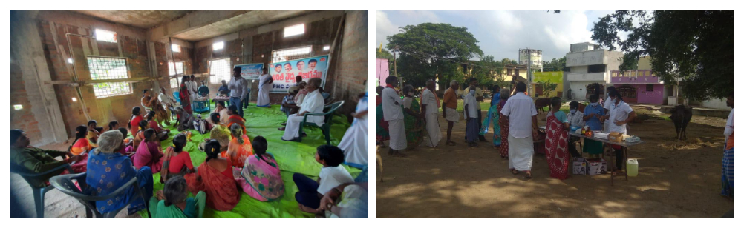Our first major activity was conducting a **door-to-door household survey**. We personally visited all 432 households in the village, introducing ourselves as student volunteers and explaining the purpose of the survey. Using printed forms and direct interviews in Tamil, we identified physically challenged individuals, noted their needs, and documented their access (or lack thereof) to government

support schemes. This activity helped us build trust with the community and gather accurate ground-level data.

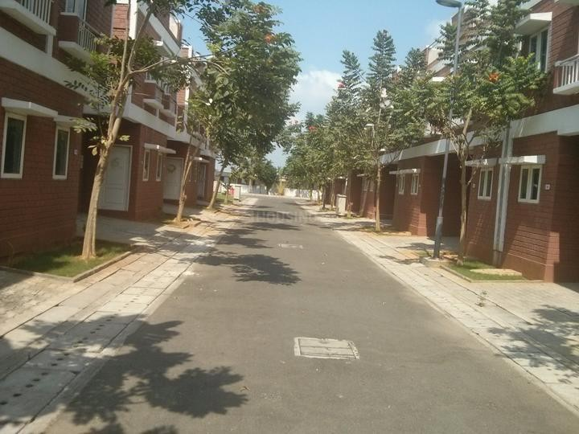

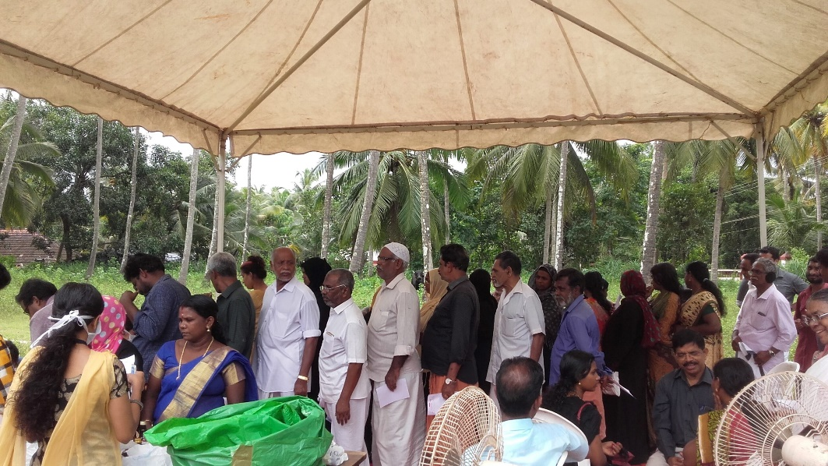

Following the survey, we organized a **community awareness session** in collaboration with the village Panchayat. The session was held in the community hall, where we used posters, charts, and real-life examples to explain government schemes such as the UDID card, disability pension, and assistive devices available under the ADIP scheme. Many villagers actively participated, asked questions, and showed genuine interest in applying for these benefits.

We also conducted a **basic medical screening camp** with the help of the local Primary Health Centre (PHC). We coordinated with the PHC nurse to assess the needs of the physically challenged and provided assistance in scheduling follow- ups for further disability certification and UDID registration. This camp helped bring health services closer to the people who had limited mobility and access.

Another key activity was **resource support and application assistance**. We sat with interested families and helped them fill out forms for disability pension and UDID registration. For those without digital literacy, we explained the process, collected the necessary documents, and facilitated the submission through online portals. We also spoke with Panchayat officials to encourage their support in verifying documents and endorsing local applications.

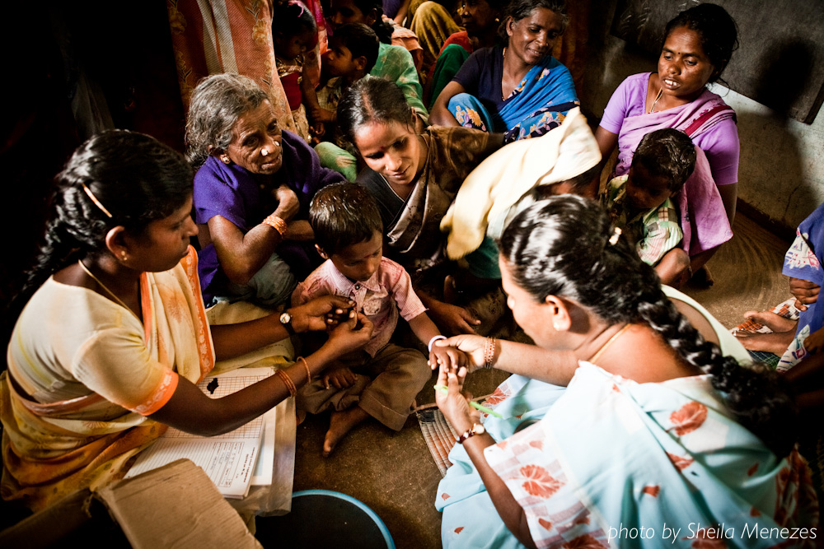

Additionally, we carried out a **physical audit of public spaces** such as the primary school, PHC, anganwadi, and the Panchayat office. We took photographs and notes highlighting the lack of ramps, handrails, and accessible toilets. This documentation was submitted along with our recommendations for infrastructural improvement.

Throughout our visit, we made a point to engage villagers in informal conversations. These interactions were not only valuable for gathering unspoken insights but also served to strengthen community bonds. Several families expressed gratitude and relief that someone had finally taken an interest in their needs.

In summary, every activity we conducted was hands-on and field-based. From identifying issues to proposing solutions, we took ownership of every step in the process. The experience was deeply humbling and taught us the real meaning of inclusive development. Our goal is now to ensure that these activities continue through local stakeholders and that the impact we made serves as a foundation for long-term change.

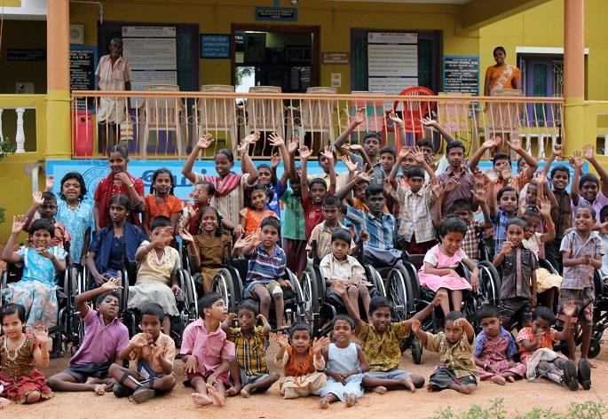

**CONCLUSION**

Our journey as part of the Unnat Bharat Abhiyan (UBA) project in Thenneri was a transformative experience, both for us as student volunteers and for the community we engaged with.

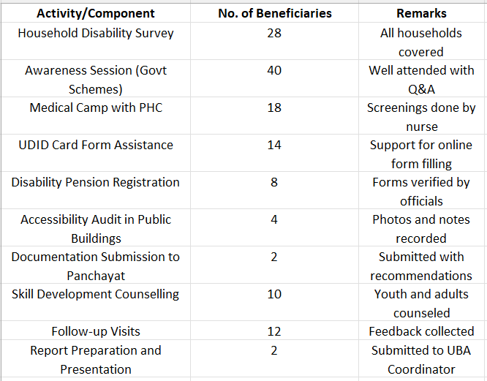

Through our household surveys, awareness sessions, health screenings, and support with government schemes, we gained meaningful insights into the challenges faced by disease caused individuals. We uncovered stories of resilience and brought attention to long-overlooked needs.

Our efforts went beyond data collection—we empowered families with information, helped initiate applications for disability benefits, and promoted

inclusive development. The project reinforced our belief that real progress begins with equal access and dignity for all.

We believe this work has laid the groundwork for lasting impact. With continued support from the Panchayat, NGOs, and future UBA teams, Thenneri can truly become a model of inclusive rural development.

We are thankful for the opportunity to serve and contribute to the vision of Unnat Bharat Abhiyan: empowering villages through collective and compassionate action.

**“Our Journey in Thenneri”**

***(Survey → Awareness → Health Camp → Application Assistance)***

